# **Travel Site**

## **Project Overview**

A travel company has approached you to design a basic travel destination website, leveraging HTML, CSS, and component thinking.

To submit this deliverable, ensure you push the last git commit to your GitHub repository before the submission deadline. Submit the link to your GitHub repository in Synapse before the submission deadline.

Pay attention to the details of the mockup, and the instructions below to successfully complete this project.

## **Tools & Resources**

* Convert a creative mockup into a functional multi-page static site using HTML and CSS
* Download the assets & mockups to get a better idea of how your project should appear
  + Keep in mind that the mockups were created for a screen size of 1280px wide.

## **Functional Requirements**

* The site must have 4 Pages:
  + Home Page
  + 3 Destinations Pages
    - Iceland
    - Greece
    - Hawaii
* The Home Page must have 4 Sections:
  + Navigation Bar
    - Will contain working links for each page
      * Logo (should link to the Home page)
      * Home
      * Iceland
      * Greece
      * Hawaii
  + Hero
  + Recommendations
    - One card for each destination
      * Must be linked to the appropriate destination page (Iceland, Greece, Hawaii)
      * Clicking anywhere on the card must go to the destination page.
  + Footer
* The Destination Pages must have 3 Sections:
  + Navigation Bar (Same as Home Page)
  + 3 Itinerary Cards for a 3 Day trip
    - Friday
    - Saturday
    - Sunday
  + Footer (Same as Home Page)

## **Visual Design Requirements**

* All pages must match the mock ups as closely as possible, being mindful of image distortion and proportions.
* The site must use the assets provided.
* Each page must have an identical Navigation Bar with the following style:
  + The Navigation Bar must be fixed to the top of the page
  + The background color must be #FFFFFF
  + The site logo/wordmark color must be #335576
  + The currently active page must be underlined using the color #DB7A4E
* Each page must have an identical footer with the following style:
  + The background color must be #FEFAF5
  + The footer titles and text must be the color #335576
  + The footer subtitles must be the color #DB7A4E
* The base font for the site must be Verdana.
* Home Page - Hero Section:
  + The hero background color must be #FEFAF5
  + The text content must be left aligned
  + The slogan color must be #335576
  + The ‘Get Started’ button background color must be #DB7A4E
* Home Page - Recommendations Section:
  + The recommendations title must have the color of #335576
  + There will be 3 Cards, one for each destination (Iceland, Greece, Hawaii)
  + The destination name must be in the bottom right corner of the card
  + The border radius of the cards must be 5px
  + The border of the cards must be 1px solid black with an opacity of 20%
  + The box shadow of the cards must be:
    - Horizontal Offset: 0px
    - Vertical Offset: 4px
    - Blur: 4px
    - Color: Black, with an opacity of 20%
* Destination Pages:
  + They must have a title with the destination name
  + The provided image asset for the destination must take up the full width/height of the background for the page.
  + They must have 3 Days of Itinerary activities including:
    - A title for the day of the week
    - 4 Itinerary activities (e.g. Breakfast, Lunch, Dinner, Snorkeling)
    - Activities must have a background of #FEFAF5

## **Implementation Requirements**

* You must use semantic tags where appropriate (e.g. header, footer, nav, etc)
* All CSS must be placed in a separate stylesheet and connected to the HTML through the link tag.
* File/Folder structure must be organized and follow the Travel Site Structure Diagram

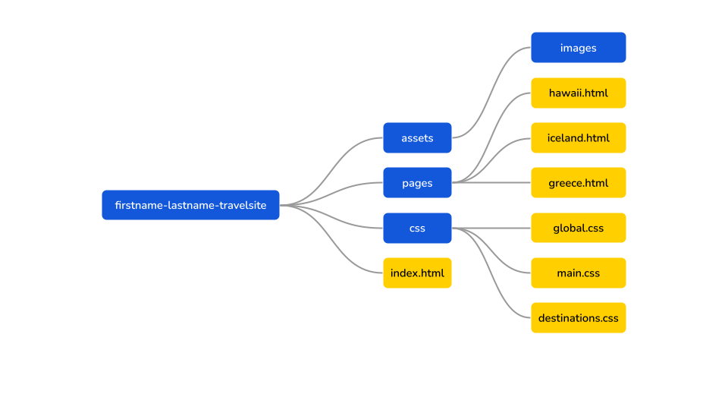

* Navigation Bar: The menu items must be specified using an unordered list
* Recommendations Destination Cards: Must use the <a> tag around the cards in order to link to the appropriate page.
* Itinerary Cards: Must use an unordered list for the itinerary activities
* Reuse as much styling and code as possible (e.g. Destination Cards and Itinerary cards), and build your project around common component code that you can reuse if possible.
* Use the BEM methodology for all your class names.
* The layout of your site must use the Box Model, the CSS display property and CSS positioning including Flexbox. For this project, you should not use floats.

## **Diving Deeper**

If you have completed the requirements above, you may go above and beyond to demonstrate skills you have been learning. However, any further features you add to the project must not conflict with the provided requirements.

Suggestions for Diving Deeper:

* Make your site responsive so that it looks good at any dimension.
* Add hover animations to links. For example, when hovering over menu items in the Navigation menu, add an underline to the hovered item. For your destination cards, change border color or add an semi-transparent overlay when hovered.
* Add a page for the “Get Started” button that has a simple form that allows a user to select a destination and provide their contact information and message that would be used to begin the booking process. The page should have the same look and feel as the rest of the site.